Oliver Zavala

Nailane Oliveira

Chris Hoyek

Maxwell Carter

Group 1 Storyboarding MODS Application

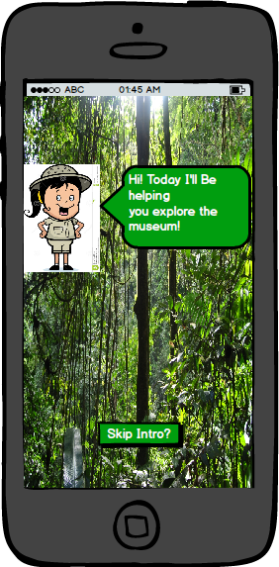

The application user opens that app and an intro animation begins and teaches them about the app’s UI (User Interface). This animation can be skipped by pressing the ‘Skip Intro?’ button.

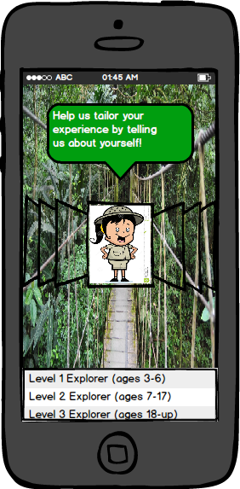

Once the intro finishes or the user skips it, they will be prompted to this page. This is where they must select their age group so that appropriate exhibits or activities come up. They choose multiple age groups or just one group. This way, they will be able to see the exhibits that are appropriate to their age level, saving them time and giving them relief from going to exhibits that may not interest them.

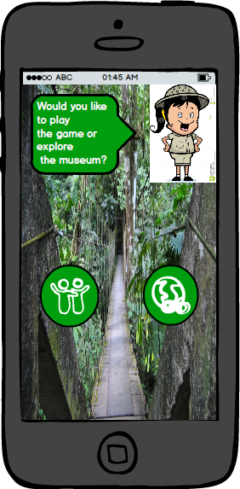

This screen essentially prompts the user if they would like to play the apps game by selecting the left button or explore the museum by selecting the right button.

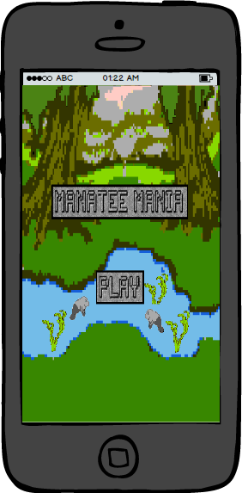

This game can entertain those that are waiting in lines at the museum and bring awareness to a problem that the museum has been trying to inform the public about- the dangers of pollution to wildlife- especially manatees. Florida manatees tend to mistake pollution such as water bottles and plastic wrappers for food, and choke on them, with a public support effort,we can organize events to help stop this.

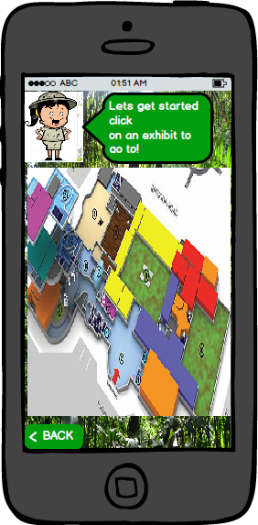

This is the interactive map. You can touch anywhere in this map and it will bring up the information for the area the user pressed. The information will include the names and small description of the exhibits, found in the area the user selected. The user will also find the location of the bathrooms.

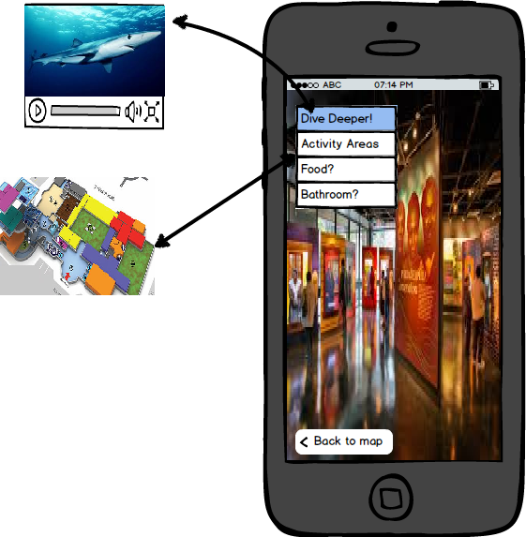

Once the user clicks on a specific exhibit on the map, they will see a 360 view or an image of it so they can get an idea of how it looks like to avoid getting confused with a different exhibit when trying to look for it. The user will also have the option to ‘Dive Deeper’ and get a small description of the exhibit and even a small video so they could decide if they are interested in seeing it. They will also see where the bathrooms are located and can click ‘Back to Map’, to continue to see where other exhibits are located.